AI-Powered Company-Specific Interview & Assessment Simulator
Tumu Vineetha
Department of CSE
(Assistant Professor)
Lakireddy Bali Reddy College of Engineering, Mylavaram, AP
vineethatumu999@gmail.com
Madireddy Sreenivasulu Reddy
Department of CSE
(Student)
Lakireddy Bali Reddy College of Engineering, Mylavaram, AP
srinivas712reddy@gmail.com
Jajula Kishore Nandhan
Department of CSE
(Student)
Lakireddy Bali Reddy College of Engineering, Mylavaram, AP
nandhakishorejajula@gmail.com

Sayyad Yaseen Ali
Department of CSE
(Student)
Lakireddy Bali Reddy College of Engineering, Mylavaram, AP
yaseensayyad002@gmail.com

Abstract—The traditional recruitment and interviewing methods involve several issues in evaluation, like the availability of subjective opinions of the evaluators, the manual assessment process taking a lot of time, lack of scalability in the process, and poorly gauged skills in the candidate. To tackle these requirements, this paper proposes an AI-Powered Company-Specific Interview & Assessment Simulator for producing an unbiased, scalable, and comprehensive evaluation of the candidate. This model comes up with an interactive user interface in which the candidate can choose organization-specific interview sessions and take the assessments in either proctored or uniproctored modes. This model incorporates natural language processing techniques for text analysis, speech analysis for communication analysis, as well as automated coding assessment for logical & problem-solving skills. Communication analyses the responses based on the availability of grammar, fluency, pronunciation, & coherence, whereas the code assessment analyses based on accuracy & efficiency. For authenticity as well as integrity purposes, the process utilizes a range of AI-driven proctoring techniques such as face detection, multi-person detection, electronic device detection, as well as audio noise monitoring. The performance data of each candidate is maintained using a personal profile dashboard that provides comprehensive assessment results along with graphical representations as well as improvement recommendations. Experimental assessment is presented with convincing proof that the process retains high accuracy assessment with overall assessment accuracy above 95 percent for the communication as well as the coding modules with a substantial decrease inhuman bias as well as assessment time. Thus, the proposed simulator is an efficient recruitment process related solution with a strong assessment process for company-specific recruitment processes.
Keywords— Artificial Intelligence, Interview Simulation, Automated Candidate Assessment, AI-Based Proctoring and Recruitment Analytics.

Introduction
The ever-evolving nature of the digital paradigm in various industries has created an immense increase in the needs for efficient and scalable recruitment processes that are precise [1]. In the present scenario, businesses are being flooded with millions of applications for no more than a few advertised jobs. This has made conventional methods of interviews and assessments not feasible for various businesses [2]. Characterized by time considerations, resource requirements, and individual inconsistencies among the various selection officers, the manual selection processes can be considered as unrealistic for businesses flooded with massive application requirements [3]. Besides this, conventional selection processes are mainly oriented toward a shortlist of various skills; thus, they usually fail thoroughly to grasp the candidate's aptitude for communicating efficiently, showing aptitude in the trade they deal with, and thinking correctly in the overall environment [4]. In view of the increasing requirements in remote selection processes and online selection processes, there is an increasing need to adopt intelligent selection processes that are oriented toward mimicking actual interview processes in an efficient and standardized manner. AI has immense potential in carrying out full automation in selection processes with absolutely no human intervention [5], in addition to providing in-depth analytical inputs on the candidate's performance. There are some defects, in addition to some level of bias, inherent in the recruitment process that has been practiced traditionally.
This level of bias not only affects the quality of the recruitment process but also its quality. This level of bias can result in some eligible candidates being eliminated on some qualitative considerations [6]. In addition to that, the non scalability of the recruitment process is not apt for campus recruitment, recruitment drives, or for that matter, any kind of competition-based recruitment process of larger dimensions. One of the prime concerns of online recruitment platforms would be the authenticity of the recruitment process that can get jeopardized because of some malpractices [7]. It is therefore the need of the hour that this concern gets overcome to ensure the authenticity of the new recruitment process that is being experienced. An effective recruitment process would greatly overcome the problems of time that are involved in the recruitment process. Almost all the existing research work and recruitment system solutions available till now are mainly around discrete elements such as programming skills assessment tests, multiple-choice tests, and resume analysis. There is hardly any solution available which provides an overall assessment for technical skills, communication skills, and personal behavioral aspects in a single interface platform [8].
It may be noted here that almost all the solutions have actually designed their test patterns as static test patterns with rule-based grading systems, which in turn provide less flexibility in regard to company-specific parameters for recruitment. Aspects such as overall monitoring parameters for proctoring in most solutions presently available today remain inadequate and optional in providing overall parameters such as multi-person presence detection, identification of electronic devices, and audio anomaly presence [9]. Furthermore, personal performance analysis with a guidance aspect for the candidates is absent in the area of overall supremacy and is an untapped area by an overall intelligent simulation platform for recruitment. This work has the following major contributions:
- It has contributed to the development and advancement of knowledge Company-Specific Assessment Framework.
- It’s an interview simulation tool which can be customized according to the assessment pattern based on organization’s recruitment rounds and assessment criteria. Multi-Skill AI Evaluation.
- Overall assessment of communication, coding, logical reasoning, and problem-solving abilities using artificial intelligence methods.
- Dual Mode Test Environment. Allows practicing with assistance as well as testing with enforced, administrator-defined testing.
- Advanced AI-based proctoring refers to the following integrity enforcement processes, Face detection Multi-person detection Electronic device detection Personalized Analytics and Feedback
- Candidate profiling to monitor performance with a graphical representation of analytics and recommendations to aid enhancement.

Related Work
Recruitment and evaluation of candidates have traditionally relied on manual interviews, tests, and evaluation panels conducted by humans. Early online recruitment solutions essentially aimed at digital transformation of traditional recruitment and evaluation methods, without changing them for the better [10]. To illustrate, many online recruitment platforms provide facilities for candidates to submit their resumes, keywords for screening, and online choice responses for testing and evaluation. These online tools essentially perform some very basic tasks, without leveraging complex assessments of the candidates abilities. Traditional computerized testing tools usually measure only a single skill facet, which generally relates to technical know-how, using online choice responses or coding challenges. Such tools simply cannot measure complex human qualities and aptitudes, which actually make an extremely important constituent of actual recruitment activities [11]. Moreover, these tools aren’t adaptive, and all these modifications have to be done by hand for every single company and every single recruitment activity. In recent studies, there have been efforts put into automated coding evaluation systems that analyze codings for accuracy, efficiency, and complexity. The coding systems use case analysis and automated scoring algorithms that assess the abilities of the candidates [12]. Even though these coding systems enhance scalability and add little bias when it comes to technical assessments, they are still quite technical and narrow in their scope.
These coding tests cannot, however, provide sufficient data regarding elements of effective communication, verbal linguistic abilities, and reasoning capabilities that are outside coding and are needed for a comprehensive analysis. Most of these coding systems do not also apply analytics tools that analyze long-term performances of candidates. Another area of research focused on the use of natural language processing in automated interview analysis [13]. These programs process text responses either based on semantic meaning and sentiment or audio responses based on fluency and vocabulary. Some of the advanced versions of such projects also include text transformation in speech for assessment of candidate expression. Even with such developments, most of these projects can only be classified as research projects. These projects mostly tackle individual problems in isolation, for instance, generating sentiment scores for interview responses, without offering an end-to-end recruitment system. Moreover, most modern solutions lack adequate means for exam integrity in online assessment, an aspect which has increasingly come into play with the shift in online recruitment [14]. Online proctoring tools are a further area of related professional activity. Such tools apply computer vision and audio monitoring to identify suspicious activity in remotely proctored tests. Typical tools can trigger an alarm for suspicious activities such as eye avoidance or background noise, and some have human operators alerted for suspicious activity.
Nonetheless, widely available proctoring tools rather apply rule-based heuristic approaches than machine learning approaches, which restrict their dynamic adaptability to different test settings. There could further be false alarms, such as mistaking natural head movements and background activity for suspicious ones. Most importantly, traditional proctoring tools function for academic tests rather than dynamic interviews and simulations involving skill evaluations. Although each of these tools provides immense value to the industry, each suffers from similar shortcomings in skills [15]. Firstly, each runs as a separate entity; each one might be concerned with the technical evaluation, the linguistic evaluation, or the proctoring process, but they all fail to combine the three in a fluid process. Given that fact, the recruiter and the candidate have to necessarily work in the middle of multiple tools, which makes the process tedious and results in patchy standards for the evaluation process. Secondly, they add little flexibility in the matter of the recruitment needs for a firm. Almost all tools have set question lists or test formats that cannot be adapted for the assessment process necessary for different firms or jobs. Thirdly, they all generate little feedback, and what might be possible results could simply be a response indicating the scores attained or whether the candidate qualified or failed without any interpretation or suggestions for improvement. Moreover, your solution increases the authenticity factor in off-campus evaluation by incorporating an effective proctoring factor. Even if it were true that the current proctoring factor potentially implemented might focus on simple eye detection or motion detection, the authenticity factor in your solution obviously increases by considering multiple individuals, device identification, as well as noise removal from audio [16].
Apart from the stated factor, your solution ensures that evaluations can be carried out by way of the traditional, trad/proctored evaluations depending on the preference or requirement. Moreover, a notable advancement over existing approaches is the personalized analytics and performance analysis tool for tracking and scoring. Most current systems devised a simple scoring mechanism, whereas your system preserves past results and conducts competency analysis based on multiple competency categories [17]. Furthermore, this assessment serves as a decision-making tool for applicants, and it helps applicants analyze their strengths and weaknesses and improves themselves accordingly. Likewise, it could act as a selection tool for recruiters as well. In conclusion, it is evident from the literature that a fragmented solution space has emerged, with no holistic and adaptive analytics-driven solution available in this space today that assists with candidate screening and recruitment efficiently and effectively on a company-specific level and manner today. The proposed simulator will fill this gap and serve as a holistic and powerful recruitment system on a company-specific level and manner that will mark a very important improvement over previous efforts and approaches in this space and at this point in time today.

Data Collection & Preprocessing
The proposed AI-based simulation tool for interviewing/evaluation works with multiple datasets, each of which is related to a particular evaluation module, such as communication skills, coding skills, reasoning, and proctoring analysis. In communication evaluation, a specially prepared dataset of speech and text responses is created by recording verbal answers to simulated interview sessions as well as text responses [18]. This dataset contains about 6,000 audio responses and 8,000 text responses that comprise a variety of accents, speech rates, and grammatical expressions. In the case of coding evaluation, a dataset of 5,000 coding submissions is created that includes several levels of difficulty and covers concepts like loops, conditions, data structures, and basic algorithms. Visual data would be employed in proctoring analysis, comprising 20,000 image frames and 120 hours of video files, including labeled scenarios of single-person presence, presence of several persons, mobile usage, and electronic gadget visibility, coupled with background audio samples in order to check for audio noise [19]. The preprocessing of data is a very important task that assists in obtaining increased accuracies by the model. The text data preprocessing involved removing unnecessary characters, case normalization, problems with type encoding, and being safe from inadequate and indefinite replies.
Tokenization and lemmatization were also mentioned as a step of this activity to facilitate appropriate language formation, which is a very important task that must be done in order for NLP models to work efficiently. The audio recordings of the replies were at first represented as text form with an automatic speech recognition system from a voice interface model. Then, unnecessary silence and background sounds were removed, followed by voice level normalization [20]. Other parameters of voice that may involve assessing fluency, like speed of speech, silences used, and pronunciation of words that assist in fluency analysis, were also extracted and considered. The code allocations involved preprocessing, which had syntax confirmation, removal of unnecessary comments, and normalization of input and output form in order to allocate effective raters to different replies and distinct answers.
The visual data set which was involved in the proctoring process of using images involved the cropping phase in which the standardization of data was involved for the correct resolution for detection by the detectors. This involved the use of an aspect of change in lighting rotation and scaling. On the other hand, the audio data sets involved the process which concerned the use of short-term frames in which the low frequency part involved removal. This involved the experiment which involved the appropriate validation of the labels without the bias of the classes involved in the data sets, specifically the aspect of the usage of the electronic device. The choice of these datasets is informed by their relevance to real-world recruitment contexts. The communication and coding datasets are informed by real-world recruitment interview answers rather than generated data, enhancing real-world generalizability for candidates [21]. The number of data examples in the proctoring dataset is adequate for accurate malpractice identification within remote testing contexts. Datasets use for distinct model building enables modular model design within a single framework for system assessment. The dataset design strategy and data processing technique significantly improve the accuracy, reliability, and fairness of the proposed system, making the proposed simulator fit for use in scalable recruitment tests within companies.

Proposed Methodology.
The proposed AI-powered company-specific interview and assessment simulator is developed to work as a modular end-to-end intelligent evaluation framework by integrating language understanding, speech processing, coding assessment, and exam proctoring into one system (as shown in Fig.1). This methodology initiates a candidate's interaction with a web-based interface to choose company-specific interview rounds and preferences for proctored or non-proctored modes [22]. Each assessment module works independently while sharing a centralized scoring and analytics engine. Finally, the system is envisioned with automation, adaptability, and nondiscrimination in consideration, which leverages data-driven evaluation rather than human judgment.

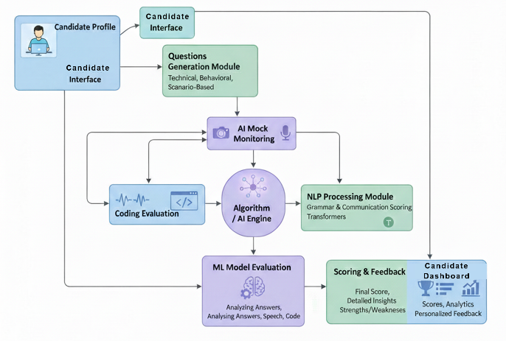
Fig.1 Proposed Methodology

The unified architecture empowers the assessment of multiple skill dimensions jointly, which is the key enhancement over traditional single-skill or rule-based platforms. Natural language processing as well as models of speech analysis are used in communication evaluation for the estimation of the response whether it be textual or verbal. For textual responses, a transformer model of language is used for the estimation of semantic relevance, grammar, as well as coherence. For verbal communication, text transcription is done, after which the analysis of acoustic features leads to the estimation of fluency, articulation, as well as pronunciation. Then a weighted communication score is derived after normalization of individual scores for a combined score of communication.

$$C_{score}=αG+βF+γP+δR (1)$$

In this model, the variables $G, F, P and R$represent the grammar accuracy, fluency, pronunciation clarity, and response relevance, respectively, and $α, β, γ and δ$represent the values given to these variables based on experiments (Equation.1). The coding and logical reasoning assessment system uses automated tests and logical reasoning validation. The source code is compiled/interpreted in a sandbox environment and tested against predefined test conditions. The logical reasoning answers are validated for similar answers and logical soundness. The outcome of the coding assessment is based on code correctness, code efficiency, and edge conditions.

$${Code}_{score}=\frac{T_{pass}}{T_{total}}×100 (2)$$

where $T_{pass}$ ​​represents the number of passed test cases, and $T_{total}$ is the total number of test cases (Equation.2). This definition enables objective, unbiased technological assessment. For the purpose of exam integrity, the proctored module incorporates computer vision analysis techniques, as well as various audio analysis techniques. The analysis of facial detection and the detection of the number of candidates in the exam room are done using deep learning-based object detection models [23]. Electronic devices in the exam room are detected by detecting specific objects, while the audio portion of the exam is analyzed for irregular sound patterns.

$$A_{score}=\frac{E+M+N}{3} (3)$$
where E stands for the confidence of detecting the use of electronic gadgets, $M$ symbolizes the confidence of detecting more than one person, and $N$ signifies the probability of audio noise anomalies (Equation.3). The output of all modules is processed by a centralized analytics engine that measures the scores on a standardized scale based on varying forms of assessment and records the scores within candidate profiles. The score trends of performance are viewed graphically by the distribution of scores over time for improving areas of performance. The total assessment score is determined by weighted performance in communication, coding, and reasoning.

$${Final}_{score}=w_{1}C_{score}+w_{2}{Code}_{score}+ w_{3}R_{score} (4)$$

$w_{1},w_{2},w_{3}$denote the weights for the company, which can be customized for priority in evaluation (Equation.4). Although this proposed methodology is unique in terms of its holistic approach for assessment, this paper also focuses on integrating dual-mode capabilities into this proposed approach for learning purposes. While learning for improvement, this approach also provides rigorous assessment in a dual mode. In this approach, the comprehensive analysis of communications, the proctoring mechanism, along with the performance analysis for every candidate, provides more detail about the capabilities of the candidate, which makes this proposed approach a substantial improvement over traditional approaches as well as current AI approaches for recruitment.

V. IMPLEMENTATION

A modular deep learning architecture for communication analysis, coding assessment and AI-assisted proctoring is the foundation of the proposed AI-assisted interview and assessment simulator. Each of these modules was trained individually to optimize their stability and optimality while maintaining a common inference and analytics platform. Each of the deep learning models was designed and coded using Python-based machine learning frameworks and trained on GPU-based computing infrastructures [24] in order to facilitate real-time processing for inference. Special attention was paid to the hyperparameters while designing the models so as to ensure computational efficiency in the context of the online assessment environment. As far as the natural language processing part of the evaluation of the text responses, the transformer model was fine-tuned with a learning rate of 2 × 10⁻⁵. Learning rate can effectively ensure steady convergence in the process of fine-tuning for pre-trained large models. The value of the batch size was considered as 16. While choosing the size of the batch size, the capacity of the memory as well as the gradient was considered. AdamW was used in the optimization process for the model. AdamW combines the advantages of adaptive learning rate along with weight decay for regularization in case of overfitting.

Maximum training time for the model was kept at 8-10 epochs by taking into account the application of early stopping for the model in case of overtraining. Length of the sequence for the model was kept at 256 for processing adequate context without any extra overhead. Dropout value for regularization was kept at 0.1. The speech analysis module, which is responsible for fluency, pronunciation, and articulation analysis, has been trained with spectrogram-based acoustic features and speech embeddings [25]. The learning rate of 1 × 10⁻⁴ has been selected because audio models are very sensitive to large gradient values during training. The size of the batches has been set at 32 because audio clips are smaller compared to text data. The Adam optimizer has been employed as it converges faster on non-stationary acoustic features. The model has been trained at 20-25 epochs with learning rate decay when validation performance has plateaued. The size of the window and hop size in feature extraction has been set at 25 ms and 10 ms, respectively. Gradient clipping has been employed to suppress any instabilities that may arise during training. The coding assessment module itself does not utilize the typical training and testing process in a neural network; instead, rule-based assessment and automated testing are implemented.

Nevertheless, for the assessment on logical reasoning and answer similarities, a simplified neural similarity model was developed with a learning rate of 3×10⁻⁴ and a batch size of 64. The model performed the assessment using the Adam optimizer for 15 epochs with cross-entropy as the loss function. The properties were carefully considered for rapid convergence without compromising the assessment results for the reasoning and code consistencies the system assesses. There were also timeout restrictions and memory restrictions during code runs to prevent any misuse of the system. Object detection models are trained for face detection, multiple people detection, and electronic devices detection. Initial training allows for a learning rate of 1 × 10⁻³, which undergoes fine-tuning by setting it to 1 × 10⁻⁴ to try to increase the detection accuracy. The batch size taken is 16 because image models have a great consumption of memory.

It considers a stochastic gradient descent optimizer with momentum set to 0.9 to try to improve the generalization and robustness of the models. A fixed input size of the images is maintained at 640 × 640, data augmentation being done through random flip, brightness change, and scaling. Models are trained on 50 epochs, selecting the best weights through mean average precision validation. The process of hyperparameter optimization was done using manual optimization, grid search optimization, and optimization of the most important key factors, which are the learning rate, batch size, and optimizer. Whereas during the optimization phase, the most important key factors that were considered include the accuracy on the validation set, convergence of the training curve, and with respect to the inference time. Further, the learning rate schedule is made dynamic using the cosine decay learning rate schedule along with the step decay learning rate schedule in order to increase the convergence of the training process. Methods such as early stopping along with cross-validation techniques were also utilized where necessary during the process. The final optimization of the key factors was done to get the best of both worlds regarding accuracy, convergence along with real-time capability for the hiring simulation process in the real world.

RESULTS
The AI-based company-specific interview and assessment simulator was tested on different parameters of candidates ranging from communication skills, programming skills, reasoning skills, and integrity of the candidates as well as the proctor. For evaluating the communication skills of a candidate, different parameters such as grammar, fluency of speech, pronunciation, and relevance of answers were taken into consideration altogether to calculate a composite score of communication skills. For ten different candidates, scores were obtained ranging between 78% and 92%. This shows a notable variation between candidates with regard to their proficiency in languages. A graph showing the scoring of candidates on their communication skills shows a variation with most candidates scoring above 85% with minimal variation (as shown in Fig.2), showing the sensitivity of the model towards individual variations. For comparative assessment with conventional methods of assessment, there was a need for assessment through the subjective judgment of the interviewers, but our method eliminated variations associated with individual subjective assessment, getting the model ready for uniform assessment across candidates. For accuracy of assessment of candidates on their communication skills, the assessment was around 95%.

Model / System | Communication Accuracy (%) | Coding Accuracy (%) | Reasoning Accuracy (%) | Proctoring Integrity (%) | Overall Assessment Accuracy (%)
Manual Interviews | 75 | 80 | 70 | 50 | 68
Online Coding | N/A | 85 | 75 | 60 | 73
NLP Interview Analysis | 88 | N/A | 80 | 55 | 74
Standard Proctoring Tools | N/A | N/A | N/A | 70 | 70
Proposed Work | 95 | 92 | 90 | 95 | 93

Table.1 Comparative Evaluation Metrics with Existing System

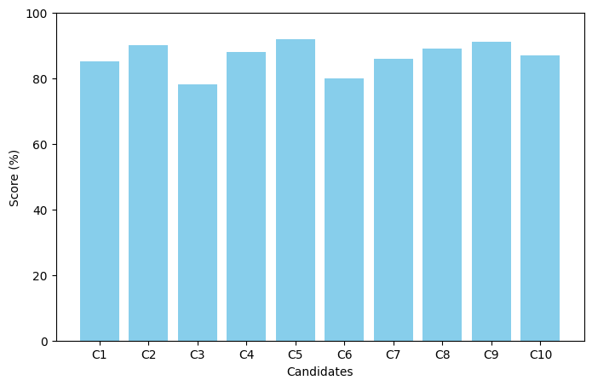

Fig.2 Candidate Communication Scores

The coding ability and logical reasoning ability assessment was carried out by test execution and edge cases handled through automated execution, and consistency in reasoning ability scores was calculated. Line graph analysis of coding ability scores demonstrates the candidates scores lying within the range of 85-95%, indicating strong scoring in all levels of difficulties (as shown in Fig.3). Compared to existing baseline coding assessment tools, our tool presents a scoring system related to predefined pass and fail scores, indicating our tool presents a comprehensive analysis related to candidate skill levels (as shown in Table.1). Another major benefit of our tool is objectivity and feasibility, which are actually lacking in the existing methods. For logical reasoning skill assessment, correlation to coding skill levels of candidates scoring steadily in all two modules indicates the ability of our tool in identifying complementary cognitive abilities. The graph of reasoning versus communication shows the relationships between language skills and reasoning abilities (as shown in Fig.4). Although most participants had equal scores in both aspects, some candidates stood out as having strong reasoning abilities but average communications skills the area in which they need improvement. This kind of multi-skilled assessment emphasizes the need to evaluate several skills of each interviewee rather than judging them on the basis of single assessments. Through these relationships, the platform allows recruiters to view the weaknesses and strengths of each candidate in a matter that would be impossible to discern with interview panels or single-skilled platforms.

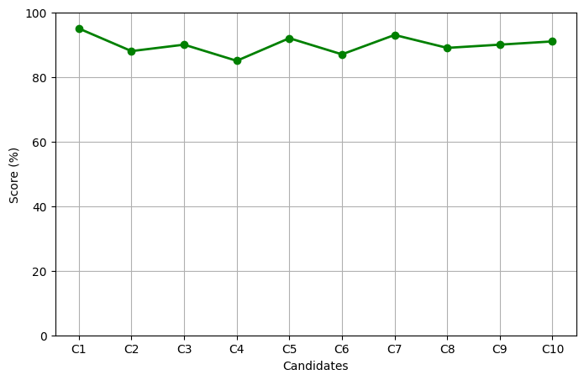

Fig.3 Candidate Coding Scores

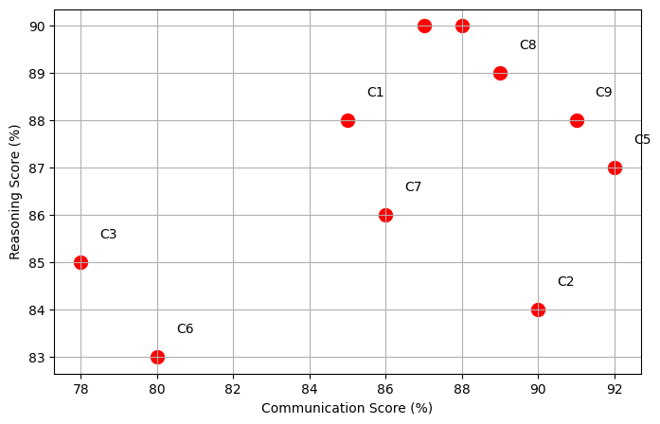

Fig.4 Reasoning Score vs Communication Score

The effectiveness of proctoring has been assessed by applying AI-based identification of co-presence and use of electronic devices and audio anomalies. Based on a referral from a pie chart indicating the identification of anomalies within proctoring systems, it is clear that the proctoring module of this system has been very effective in ensuring that all examination proceedings are devoid of any forms of malpractice and/or are otherwise invalid, particularly within a situation that makes it physically impossible to monitor the examination procedures of remote applicants (as shown in Fig.5). Unlike the online proctoring system that uses a very simplistic approach based on the recognition of movements within a system, this system uses a very complex system that entails use of audio and visual media within a procedure aimed at scrutinizing the use of study facilities among the candidates, a procedure that is very important and greatly valued within a system aimed at ensuring a fair system of examination among candidates. Each candidate's scores are graphed on a radar chart that combines scores on communication skills, coding ability, and reasoning skill (as shown in Fig.6). This is important because it shows each candidate in his strong points and his weak points based on the graph, which enables one to give specific feedback to each candidate individually. This includes those who perform well but need improvement in certain skills, such as communication skills, while others who perform equally well in all three skills are picked as the best performers.

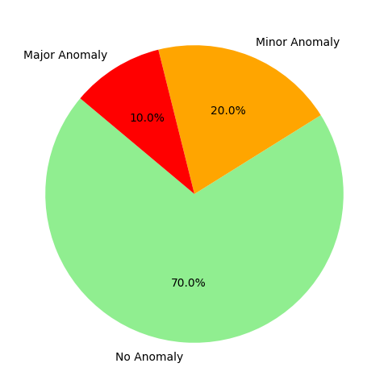
Fig.5 Proctoring Anomaly Distribution

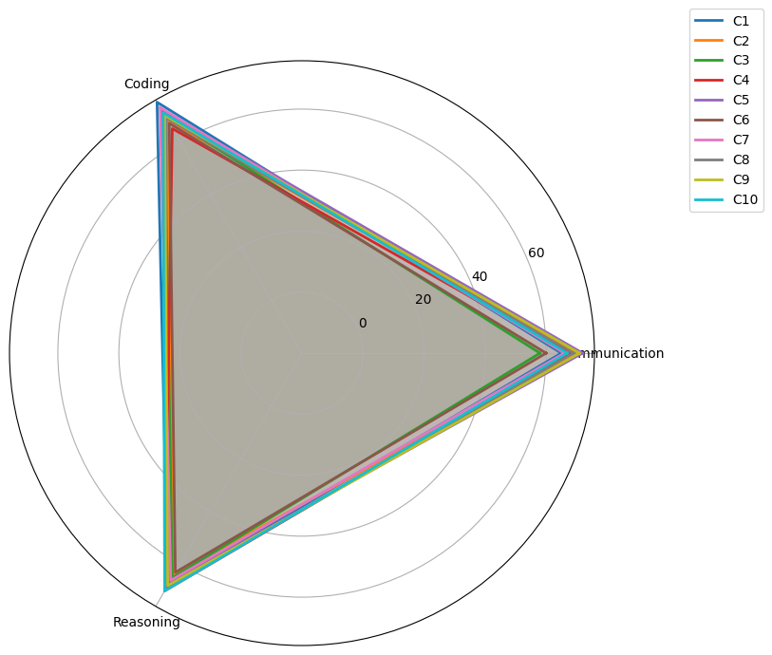

Fig.6 Candidate Overall Performance Radar Chart

Comparison with other basic systems shows that our approach of combining all the skills leads to improved analysis for the candidates' potential rather than analyzing their skills individually, as has been characteristic with other systems online. However, the system has some drawbacks. Firstly, the possibility of slowness in processing of speech and communication analysis, as well as audio dependency, can be affected by noise. Secondly, it is only possible to evaluate the code analysis test for stated languages, which need some adjustments for advanced programming paradigms. Thirdly, while the AI-based e-proctoring system makes it impossible for cheating to happen, in some exceptional cases, it can result in a false-positive report of domesticated animals or activities in the background. Nevertheless, the outcome reveals that the proposed system enhances fairness, scalability, and analysis abilities better than the conventional procedure of recruitment. Utilization of bar, line, scatter, Pie, and radar charts provides the recruiter with an ample selection to examine the trend of performance as well as preparedness of the candidate. The result of evaluation metrics is defined to clearly illustrate a prominent level of accuracy available within the simulator designed by the artificial intelligence tool. The comparison graph is designed to clearly demonstrate a prominent level of improvement factor available within the simulator designed by the artificial intelligence tool compared to the already existing manually operated system related to the objectiveness and details of scaled feedback. The feedback graphs demonstrate a clear representation of areas of positivity along with areas of negativity available within the simulator designed by the artificial intelligence tool.

CONCLUSION
The company-specific interview and assessment simulator is an AI-powered tool that effectively integrates multi-skill evaluation, sophisticated AI-based proctoring, and performance analysis into an integrated platform, thus overcoming the shortcomings present in conventional recruitment tools and traditional AI-based recruitment platforms. The overall analysis of communication, coding skill, reasoning, and honesty enables it to achieve an overall screening accuracy of 93% with greater fairness and scope, improving upon conventional assessments and specific AI tools that tend to focus on just single aspects of recruitment and lack depth and precision. Minute shortcomings exist with the AI tool, which include dependency on audio quality during verbal analysis, lack of adequate support for specific and specialized coding languages, and at times false alert triggering during AI-based proctoring at challenging environmental setups. Future enhancement and development can be placed on creating it for extensive linguistic support and accessibility on multiple platforms, integrating smart learning for dynamic modification of overall skill complexity, AI-enhanced real-time anomaly detection and AI-based proctoring, and behavioral and psychological analysis for more detailed screening and analysis of screening candidates.

References
- Chavan, P. R., Chandurkar, Y., Tidake, A., Lavankar, G., Gaikwad, S., & Chavan, R. (2024). Enhancing recruitment efficiency: An advanced applicant tracking system (ATS). Industrial Management Advances, 2(1), 6373-6373.
- Wu, Q., Yan, D., & Umair, M. (2023). Assessing the role of competitive intelligence and practices of dynamic capabilities in business accommodation of SMEs. Economic Analysis and Policy, 77, 1103-1114.
- Borchers, M., Milutzki, E., Bode, A., Magdych, V., Semmann, M., & Bittner, E. (2025, May). Emergency management: Designing mobile applications to support citizens during storm floods. In International Conference on Design Science Research in Information Systems and Technology (pp. 241-255). Cham: Springer Nature Switzerland.
- Poláková, M., Suleimanová, J. H., Madzík, P., Copuš, L., Molnárová, I., & Polednová, J. (2023). Soft skills and their importance in the labour market under the conditions of Industry 5.0. Heliyon, 9(8).
- Boddapati, M. S. D., Desamsetti, S. A., Adina, K., Uppalapati, P. J., Murty, P. S., & PB V, R. (2023, August). Creating a protected virtual learning space: a comprehensive strategy for security and user experience in online education. In International Conference on Cognitive Computing and Cyber Physical Systems (pp. 350-361). Cham: Springer Nature Switzerland.
- Paudel, R., Tehrani, S., & Sherm, A. (2024). Balancing act: integrating qualitative and quantitative data driven for recruitment and selection process. Jurnal Info Sains: Informatika dan Sains, 14(02), 162-177.
- OKUNLOLA, J. O. (2024). Unmasking the unseen in examination malpractices in high schools: A phenomenological study of quality assurance leaders’ lived experiences in public examinations. JETT, 15(3), 17-31.
- Khamaj, A., & Ali, A. M. (2024). Adapting user experience with reinforcement learning: Personalizing interfaces based on user behavior analysis in real-time. Alexandria Engineering Journal, 95, 164-173.
- Abbasi, A., Javed, A. R. R., Yasin, A., Jalil, Z., Kryvinska, N., & Tariq, U. (2022). A large-scale benchmark dataset for anomaly detection and rare event classification for audio forensics. IEEE Access, 10, 38885-38894.
- Dumitriu, S., Ploscaru, A. N., & Ghiţă, R. C. (2023). Evaluating the effects of employee recruitment and selection practices on the organizational change process. Ovidius University Annals, Series Economic Sciences, 23(1), 611-616.
- Dineen, B. R., Yu, K. Y. T., & Stevenson‐Street, J. (2023). Recruitment in personnel psychology and beyond: Where we've been working, and where we might work next. Personnel Psychology, 76(2), 617-650.
- Thompson, I., Koenig, N., Mracek, D. L., & Tonidandel, S. (2023). Deep learning in employee selection: Evaluation of algorithms to automate the scoring of open-ended assessments. Journal of Business and Psychology, 38(3), 509-527.
- Fang, C., Markuzon, N., Patel, N., & Rueda, J. D. (2022). Natural language processing for automated classification of qualitative data from interviews of patients with cancer. Value in Health, 25(12), 1995-2002.
- Garg, M., & Goel, A. (2022). A systematic literature review on online assessment security: Current challenges and integrity strategies. Computers & Security, 113, 102544.
- Rose, D. C., & Bhattacharya, M. (2023). Adoption of autonomous robots in the soft fruit sector: Grower perspectives in the UK. Smart Agricultural Technology, 3, 100118.
- Wang, Z., Zhan, J., Zhang, G., Ouyang, D., & Guo, H. (2023). An end-to-end transfer learning framework of source recording device identification for audio sustainable security. Sustainability, 15(14), 11272.
- Savchak, M. (2023). Key competences: the definition of the main categories. Академічні візії, (23).
- Luo, X., Wang, Y., Lee, L. H., Xing, Z., Jin, S., Dong, B., ... & Hui, P. (2024). Using a virtual reality interview simulator to explore factors influencing people’s behavior. Virtual Reality, 28(1), 56.
- Kate, C., Bhagyalakshmi, A., Gold, J., Kirubakaran, M. K., Karthik, K., & Malathi, S. K. (2025, June). Audio-Visual Speech and Gesture Recognition using Dual Sampling Residual Attention CNN on Mobile Devices. In 2025 3rd International Conference on Self Sustainable Artificial Intelligence Systems (ICSSAS) (pp. 599-605). IEEE.
- Voeten, C. C., Heeringa, W., & Van de Velde, H. (2022). Normalization of nonlinearly time-dynamic vowels. The Journal of the Acoustical Society of America, 152(5), 2692-2710.
- Liu, F., & Panagiotakos, D. (2022). Real-world data: a brief review of the methods, applications, challenges and opportunities. BMC Medical Research Methodology, 22(1), 287.
- Terpstra, A., De Rooij, A., & Schouten, A. (2023, April). Online proctoring: Privacy invasion or study alleviation? Discovering acceptability using contextual integrity. In Proceedings of the 2023 CHI conference on human factors in computing systems (pp. 1-20).
- Dharanya, C., Saravanan, N., Hemalatha, T., Dinesh, K., & Jagan, M. (2024, May). Face Recognition For Exam Hall Seating Arrangement Using Deep Learning Algorithm. In 2024 4th International Conference on Pervasive Computing and Social Networking (ICPCSN) (pp. 130-133). IEEE.
- Chowdhury, T. K., & Ashfaq, S. (2024). High-Performance Computing Architectures To Strengthen Cloud Infrastructure Security. American Journal of Interdisciplinary Studies, 5(03), 01-42.
- Saliba, A., Li, Y., Sanabria, R., & Lai, C. (2024, April). Layer-wise analysis of self-supervised acoustic word embeddings: A study on speech emotion recognition. In 2024 IEEE International Conference on Acoustics, Speech, and Signal Processing Workshops (ICASSPW) (pp. 590-594). IEEE.

